Moving Average Based Model
Introduction
Moving average strategies find applications across quantitative finance for capturing trend-following by smoothing price action over time. A simple crossover strategy based on a classic simple moving average produces a buy signal when the shorter average crosses higher than the longer average, and a sell when it drops below it. Simple and effective within trend, these types of systems tend to lose their way amid frequent false signals, weak risk control, and inconsistent performance in sideways markets.
In this section, we concentrate on creating a stronger and realistic moving average strategy for the S&P 500 ETF, SPY. We started with a conventional crossover strategy with a 50-day short-term and 100-day long-term simple moving average (SMA) as a baseline to represent a fast trend-following scheme. To find a better combination of parameters, we tried grid search with cross-validation based on a large search space. As a result of the tuning, we adopted a 7-day short-term and 200-day long-term SMA strategy with the best out-of-sample Sharpe ratio.
Building on the optimized crossover strategy, we further tuned it with the incorporation of advanced risk management elements. These encompass an Average True Range (ATR)-stop-loss mechanism to restrict downside risk, a dynamic volatility-targeted system to vary exposure on the basis of recent history, and a minimum holding time to restrict overtrading during noisy periods. We tested and compared each add-on individually and collectively.
By iteratively refining the strategy, not only did we quantify each component's contribution but also illustrated how combining traditional technical indicators with modern concepts of portfolio management has the potential to dramatically benefit out-of-sample performance under realistic backtesting conditions.

Methodology
We used an incremental development methodology to slowly add robustness and realism to our moving average strategy over time. Initial implementation had a simple crossover rule based on a 50-day short-term and 100-day long-term simple moving average (SMA) that provided a simple baseline for assessing trend-following action. This version produced long-only signals: a long position was taken when the short-term SMA crossed over the long-term SMA, and exited when it crossed back under.
In order to find a better pair of moving average windows, we used grid search with walk-forward cross-validation. The past SPY history was split into several rolling sets of training and validation windows. We calculated within each window all the possible combinations of short-term SMAs with periods from 3 to 30 days and long-term SMAs with periods of from 30 to 200 days. The out-of-sample Sharpe ratio was the performance metric that was used for selecting a model from the validation sets. It always concluded that the most suitable SMA combination was the (7, 200).
We incorporated several improvements on top of optimizing the moving average parameters to overcome the weaknesses of the original crossover model. We instituted a volatility-based adjustment to a stop-loss implemented with the 14-day Average True Range (ATR) scaled by a factor of 4 to exit trades during periods of extreme downside volatility. This minimized large drawdowns and enhanced capital protection. We then introduced a dynamic volatility targeting feature to adjust position sizes based on recent volatility. We applied a 20-day rolling window to compute realized volatility and adjusted position exposure to keep the target annualized volatility at 15%. This feature allowed the strategy to invest higher capital during tranquil times and decrease risk when markets get choppy, enhancing the risk-adjusted return profile.
In an effort to further curb overfitting and turnover, we implemented a minimum 10-trading-day holding time, which precluded the strategy from responding to near-term market noise. Last, we limited leverage to no higher than 2.0 to provide for controlled risk amplification when volatility is low without letting total portfolio risk get out of hand.
The final composite strategy incorporated all the components—optimized SMA (7, 200), ATR-based stop-loss, 15% volatility target, a minimum holding time of 10 days, and a 2× leverage limit—within a unified and realistic plan for systematic trend-following with risk management capabilities built-in.

Results
To test our moving average strategy’s performance and resilience, we performed several incremental backtests of daily SPY from 2010 through 2025. Each version of the strategy was backtested incrementally, from simple moving average crossover through the addition of features like ATR stop-loss, dynamic volatility targeting, minimum hold requirements, and leverage scaling. Isolating the impact of each feature allowed us to measure its contribution to return, risk management, and performance in terms of overall resilience.
Key performance measures such as total return, annual return, volatility, Sharpe ratio, maximum drawdown, and Calmar ratio. The chosen variants were also plotted against the buy-and-hold reference-point in order to make visual comparisons whenever applicable. The outcomes below show the impact of every design choice on strategy performance over time.

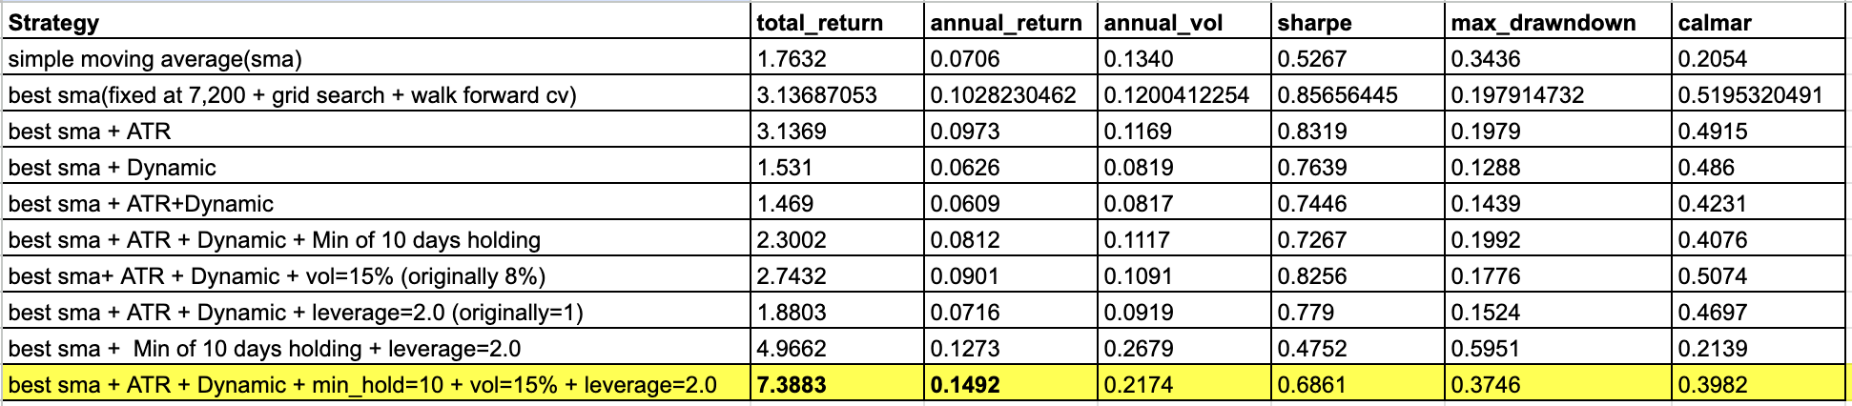
Table 1: Summary table

Of all the variants tried, the last version—combining the optimal SMA (7, 200), ATR-based stop-loss, dynamic volatility targeting at 15%, a 10-day holding time, and a 2× leverage constraint—exhibited the best overall performance. It had a total return of 7.3883, annualized return of 14.92%, annualized volatility of 21.74%, and Sharpe ratio of 0.6861.
Though the ultimate strategy did sustain a maximum drawdown of 37.46%, its Calmar ratio of 0.3982 indicates a healthy balance of return versus downside risk. This result demonstrates the success of implementing several risk control characteristics, such as volatility-based sizing and trade length constraints, at preserving performance reliability and capital efficiency simultaneously.
Table 1 summarizes the performance of each iteration of the strategy. We observe definite improvements from baseline to final combined model. Particularly, switching from a fixed volatility target of 8% to 15% and from 1× to 2× leverage made a sizable contribution to improving returns without adding undue risk. Additionally, adding the minimum holding period was key in eliminating signal noise and over-trading activity.

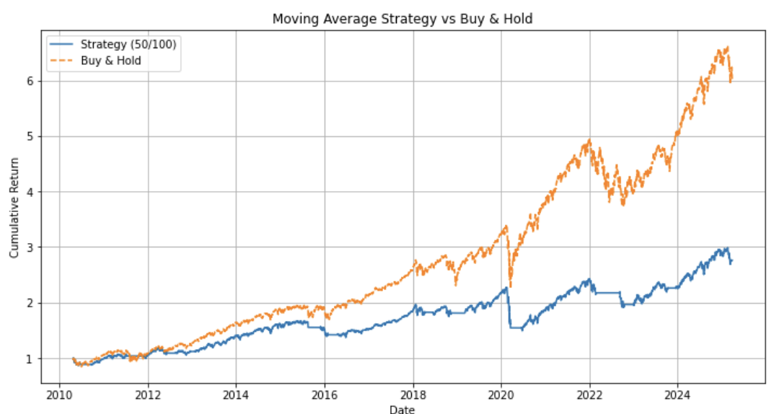Figure 1: Simple Moving Average Strategy (50/100) vs Buy & Hold
Our strategy's baseline version employs simple 50-day short-term and 100-day long-term simple moving averages. Figure 1 shows that the simple method performs worse than the buy-and-hold benchmark during our 15-year backtesting period. While the strategy avoids some of the biggest drawdowns like the 2020 COVID, the strategy trails on long-term bull markets due to its delayed entry point on exiting the position.
Its overall return is 76.3%, its return on a yearly basis is only 7.06%, with yearly volatility at 13.4%, and a 0.53 Sharpe ratio. The strategy has a maximum drawdown of 34.36%, which reflects that the simple SMA crossover signal is not sufficient for management of downside risk. The lack of position sizing along with the use of stop-loss rationale left the model vulnerable to whipsaws and long periods of drawdown with no trading occurring, creating incentive for improvement.

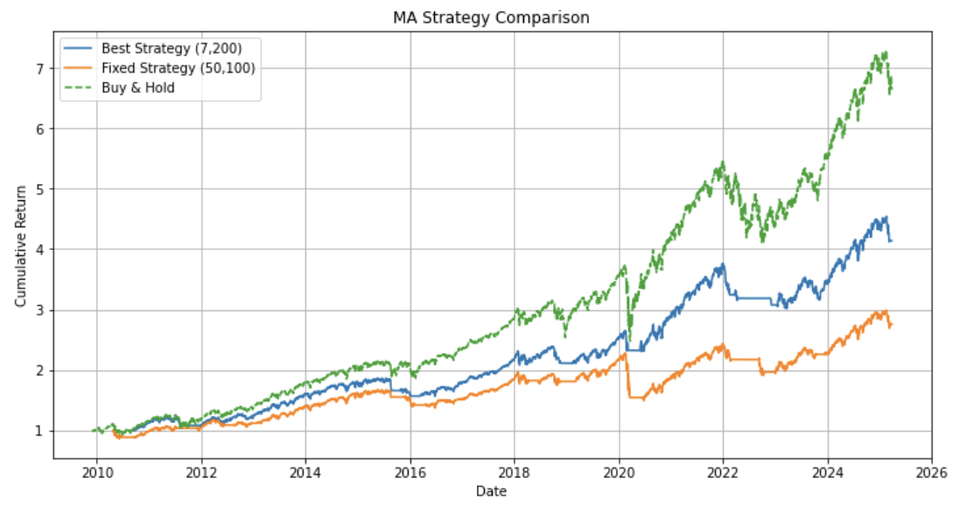Figure 2: Optimized Moving Average Strategy (7, 200) (Best SMA)
As indicated by figure 2, the optimized moving average strategy with window sizes of (7, 200) is compared with the initial fixed SMA strategy of (50, 100) and the buy-and-hold strategy. The best SMA is selected using grid search and cross-validation with walk-forward. The model of (7, 200) performs spectacularly across the board on all metrics with a total return of 213.7%, annual return of 10.28%, a Sharpe ratio of 0.86, and has the minimum maximum drawdown at 19.79%.
This strategy highlights the benefit of optimized parameter using a systematic approach. The 7-day short term allows quick reaction to momentum, with the 200-day long term mean serving as a good trend filter. The strategy beats the (50, 100) model quite handily, although the model is always inferior to buy-and-hold on an absolute return for the full time span, for the most part, due to its tendency to close out on early-phase recoveries and miss chunks of prolonged bull runs.

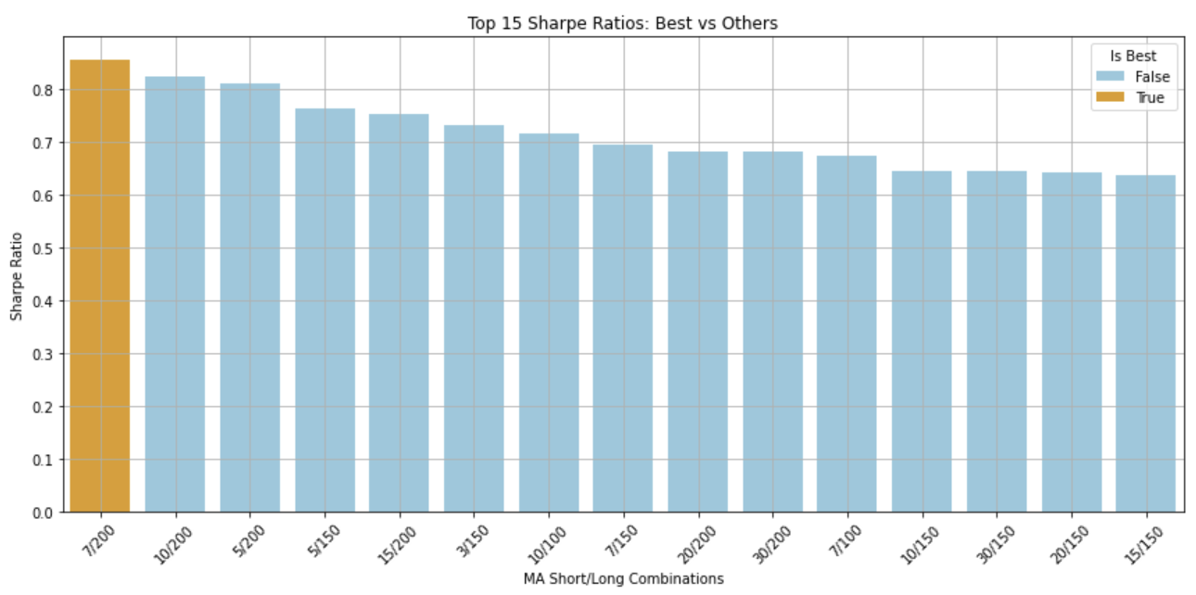Figure 3: Top 15 Sharpe Ratios across MA Window Combinations
We searched across short-term vs. long-term SMA combinations using an exhaustive grid search to find the optimal moving average configuration. Figure 3 illustrates the top 15 combinations ranked by their respective Sharpe ratios. The top-performing (7, 200) strategy had a roughly 0.86 Sharpe ratio and was better than any other combination on average. The (10, 200) and (5, 200) configurations ranked highly but fell behind somewhat on risk-adjusted return.
This confirms that windows of 5–10 days coupled with long term trend filters of 150–200 days are yielding better outcomes on SPY with early signal sensitivity and trend confirmation.

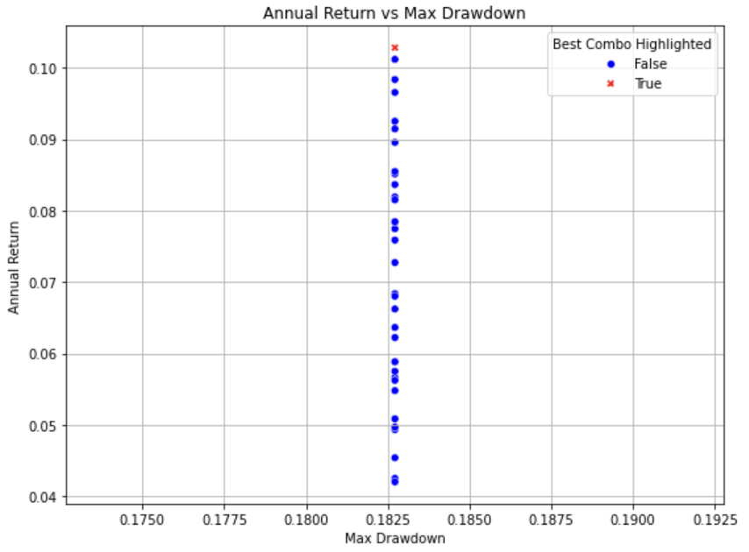
Figure 4: Annual Return vs Max Drawdown
Figure 4 shows the trade-off between annualized return and maximum drawdown across all tested SMA configurations. The (7, 200) combination is marked in red indicating that the strategy achieved one of the highest annual returns (10.28%) while maintaining a moderate drawdown (~18%), reflecting a favorable return-to-risk balance.

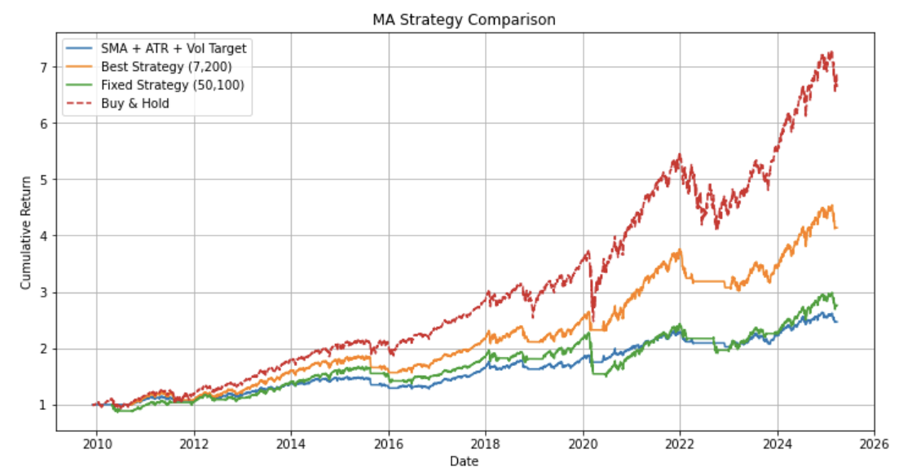Figure 5: Best SMA + ATR + Volatility Targeting Strategy vs Baselines
Figure 5 represents the performance of the strategy blending optimized SMA (7, 200) and ATR-based stop-loss along with volatility targeting at 8%. During the complete backtesting horizon, this version yielded a total return of 46.90% with the annualized return being 6.09% and annual volatility being 8.17%, which resulted in a Sharpe ratio of 0.7446. The maximum drawdown was 14.39% with a Calmar ratio of 0.4231.
In contrast to basic moving average methods, this improved version had smoother growth of equity and better risk-adjusted performance. The ATR-based stop-loss successfully capped drawdowns on bad swings of the market, and the dynamic volatility targeting mechanism ensured a steady risk profile with leverage adjustments based on market dynamics. These improvements collectively prove that incorporating risk management based on adaptability with technical signals may result in a capital-efficient and smoother trading system.

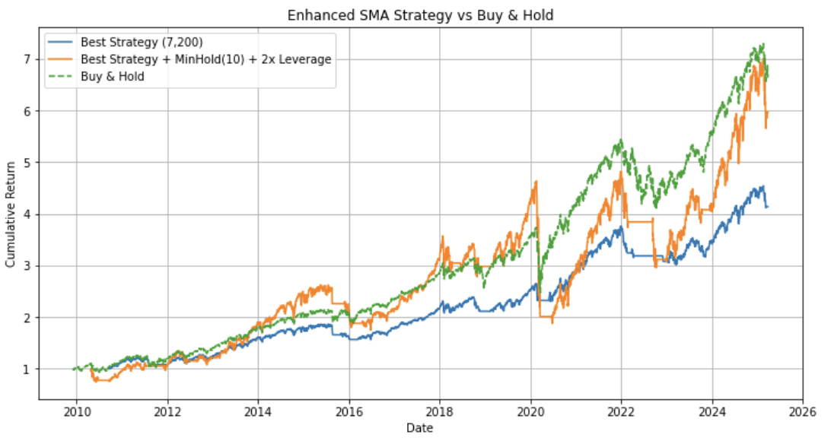Figure 6: Best SMA(7,200) + MinHold(10d) + 2x Leverage
Figure 6 is a comparison of the return performance of the optimized moving average strategy—comprising SMA (7, 200), with a minimum holding horizon of 10 trading days and a 2× leverage limit—against a simple SMA version and a buy-and-hold strategy. The optimized strategy yielded a 496.62% total return, 12.73% annual return, and volatility of 26.79%, for a Sharpe ratio of 0.4752. This increase in return, however, came at the price of a much higher maximum drawdown of 59.51%, which brought the Calmar ratio down to 0.2139.
Inclusion of a minimum holding time effectively minimized over-trading and enhanced signal stability, while leverage facilitated aggressive capitalization on long-term opportunities. Nevertheless, the higher drawdown highlights the necessity of good risk management, particularly when leverage is used. This optimized version compared to the control SMA strategy offered higher cumulative return at the expense of higher exposure to drawdown volatility—again illustrating the intrinsic trade-off between amplification of return and control over drawdown.

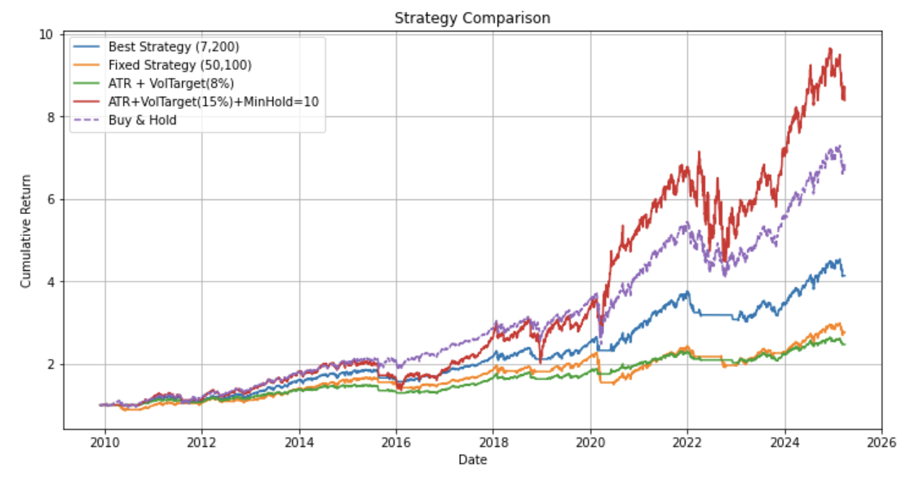Figure 7: Final Combines Strategy — Best SMA + ATR + Vol Target (15%) + MinHold=10 + Leverage Cap
Figure 7 presents the cumulative return of the ultimate, fully optimized strategy that merges SMA (7, 200) signals with ATR-based stop-loss, dynamic volatility targeting at 15%, a 10-day minimum holding requirement, and a 2× leverage limit. This iteration had a total return of 738.83%, an annual return of 14.92%, and a volatility of 21.74%, with a Sharpe ratio of 0.6861.
Though the strategy outperformed previous versions in terms of long-term performance, it also suffered a maximum drawdown of 37.46%, which reduced the Calmar ratio to 0.3982. These enhancements are largely due to efficient risk layering: the minimum holding period protected against early exits and over-trading, and the increased volatility target and leverage enabled the model to grow at higher rates during market peaks.
The strategy performed much better compared to the baseline SMA models and the buy-and-hold benchmark, especially from 2020 onward, where sharper growth resulted from the momentum alignment with the adaptive leverage. The outcome underscores the need to couple signal generation with sound position and risk management for optimal performance in actual trend-following schemes.

Conclusion and Improvements

Our moving average based model section illustrates how a basic crossover strategy using a simple moving average may be turned into a better and sustainable trading model by a series of systematic and incremental improvements. From a simple SMA (7, 200) signal, we incrementally added an ATR-based stop-loss to control downside risk, dynamic volatility targeting to scale exposure, a minimum holding time to eliminate noise-driven trades, and leverage scaling to optimize capital usage. Each improvement added to the overall improvement in performance and risk management.

The optimal strategy delivered a total return of 638.83%, a return on an annual basis of 14.92%, a Sharpe ratio of 0.6861, and a maximum drawdown of 37.46%. These outcomes are less than aggressive overfitting ambitions but represent a realistic and pragmatic trade-off between return and risk based on past market performance.

Compared with the initial version, the enhanced strategy delivered higher returns, more stable performance, and better drawdown control—demonstrating the value of combining classic trend-following signals with adaptive, data-driven risk management techniques. Future extensions could explore regime-based switching, multi-asset integration, or rolling parameter updates to further enhance robustness and out-of-sample adaptability.

Overall, this project highlights the strength of disciplined quantitative development: layering intuitive rules with empirical validation and modular design leads to increasingly effective trading strategies rooted in both theory and practical feasibility.

